LAB – Creating a SQL DB

Download instructions:

- Go to https://sqlitestudio.pl/
- Click on “Download...” at the top
- Run the file that downloads to complete download
  - Default settings should be fine

Part 1: Create database from scratch

- Go to Database → Add a Database

- Below “File”, type in the name of your database (for the purposes of this exercise, name the database “company”)

- Click on the green ‘+’ next to the input box, and specify where you would like to save the database (be sure to remember the folder and name of the database, this will be the location where the binary database file is stored).

- Press OK

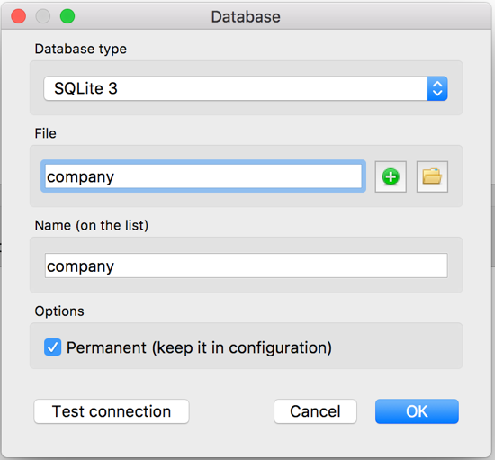

Part 2: Define tables in your database - DDL

The general syntax for creating a table is the following (discard the brackets):

CREATE TABLE [Table Name]
([Attribute1] [Attribute1 Data Type] [Attribute1 Null Constraint],
[Attribute2] [Attribute2 Data Type] [Attribute2 Null Constraint],
[Attribute3] [Attribute3 Data Type] [Attribute3 Null Constraint],
…
[LastAttribute] [LastAttribute Data Type] [LastAttribute Null Constraint],
primary key([Attribute you want as PK]),
foreign key([Attribute1] references OTHER_TABLE([Attribute1]),
foreign key([Attribute2] references OTHER_TABLE)[Attribute2]),
);

Notes:
- Don’t forget commas
- One (1) primary key definition (can define multiple attributes as 1 primary key)
- Any number of foreign key definitions
- There are other possibilities, this is just the most basic structure

- Open a new SQL editor window (look at the toolbar at the top of the screen for a paper and pencil icon)

- Make sure you are connected to your empty company database before running any code. If you don’t see company listed at the top of your SQL editor window, right click on company in the “Databases” window to the left of your screen, and click on “Connect to the database”.
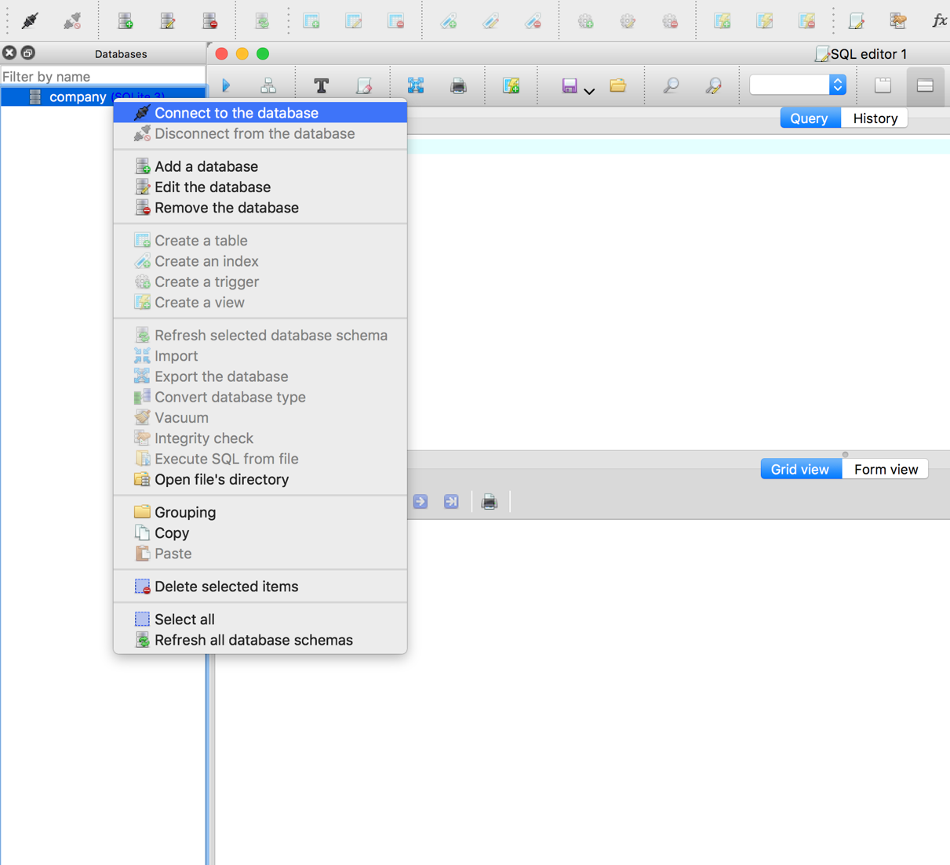

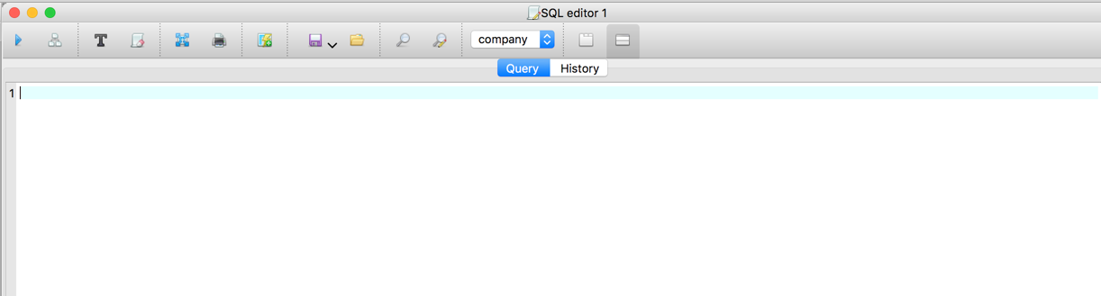

- Database Relational Schema of database to create

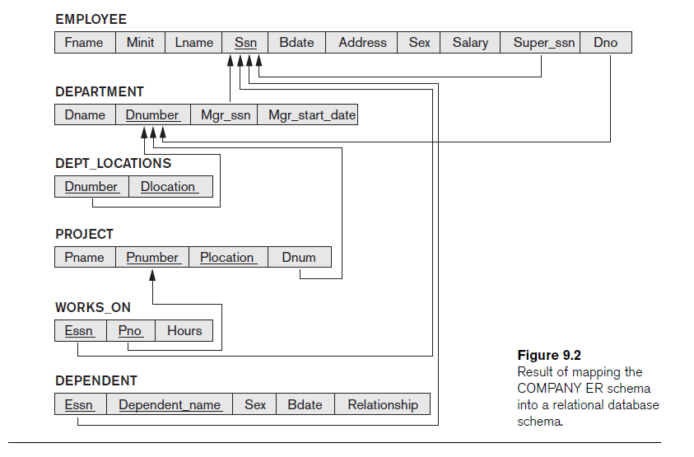

- Copy and paste the below code into the SQL editor window:
Note 1: Delete the primary and foreign key constraints (labeled in red) in the below code for now. The foreign and primary key constraints could be added after you have imported all of your data into the database. This is because trying to import data into your tables while they have compound primary key and foreign key constraints will likely result in errors.

Note 2: Another way is turn off the foreign key constraints and turn them back on after creating and importing the data.

/*
*
* The COMPANY database schema, as presented in Elmasri & Navathe Ch.3
* (page 72).
*/

create table EMPLOYEE
(Fname varchar(15) not null,
Minit char(1),
Lname varchar(15) not null,
Ssn char(9) not null,
Bdate date,
Address varchar(30),
Sex char(1),
Salary int,
Super_ssn char(9),
Dno int not null,
primary key(ssn),
foreign key(Super_ssn) references EMPLOYEE(ssn),
foreign key(Dno) references DEPARTMENT(Dnumber) ON UPDATE CASCADE
);

create table DEPARTMENT
(Dname varchar(15) not null,
Dnumber int not null,
Mgr_ssn char(9) not null,
Mgr_start_date date,
primary key(Dnumber),
foreign key(Mgr_ssn) references EMPLOYEE(ssn) ON UPDATE CASCADE
);

create table DEPT_LOCATIONS
( Dnumber int not null,
Dlocation varchar(15) not null,
primary key(Dnumber, Dlocation),
foreign key(Dnumber) references DEPARTMENT(Dnumber) ON UPDATE CASCADE
);

create table WORKS_ON
( Essn char(9) not null,
Pno int not null,
Hours double,
primary key(Essn, Pno),
foreign key(Essn) references EMPLOYEE(Ssn) ON UPDATE CASCADE,
foreign key(Pno) references PROJECT(Pnumber) ON UPDATE CASCADE
);

create table PROJECT
(Pname varchar(30) not null,
Pnumber int not null,
Plocation varchar(30) not null,
Dnum int not null,
primary key(Pnumber),
foreign key(Dnum) references DEPARTMENT(Dnumber) ON UPDATE CASCADE
);

create table DEPENDENT
(Essn char(9) not null,
Dependent_name varchar(15) not null,
Sex char not null,
Bdate date not null,
Relationship varchar(15) not null,
primary key (Essn,Dependent_name),
foreign key(Essn) references EMPLOYEE(Ssn) ON UPDATE CASCADE
);

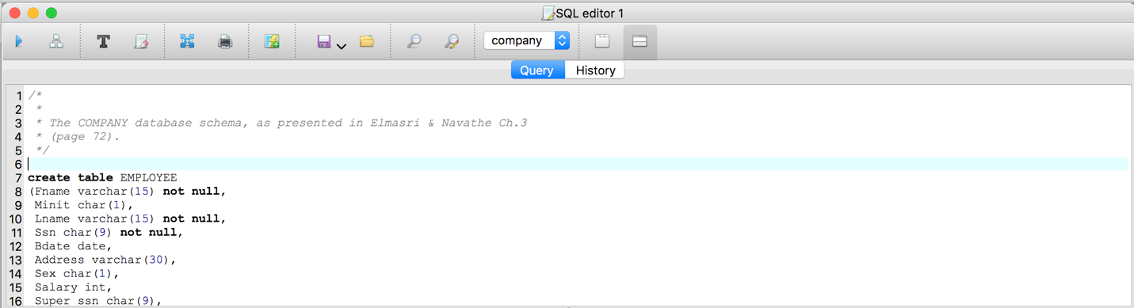

- Highlight all the code in the SQL Editor window (control+A on Windows, command+A on Mac), then click on the ‘Execute Query’ icon in the top left:
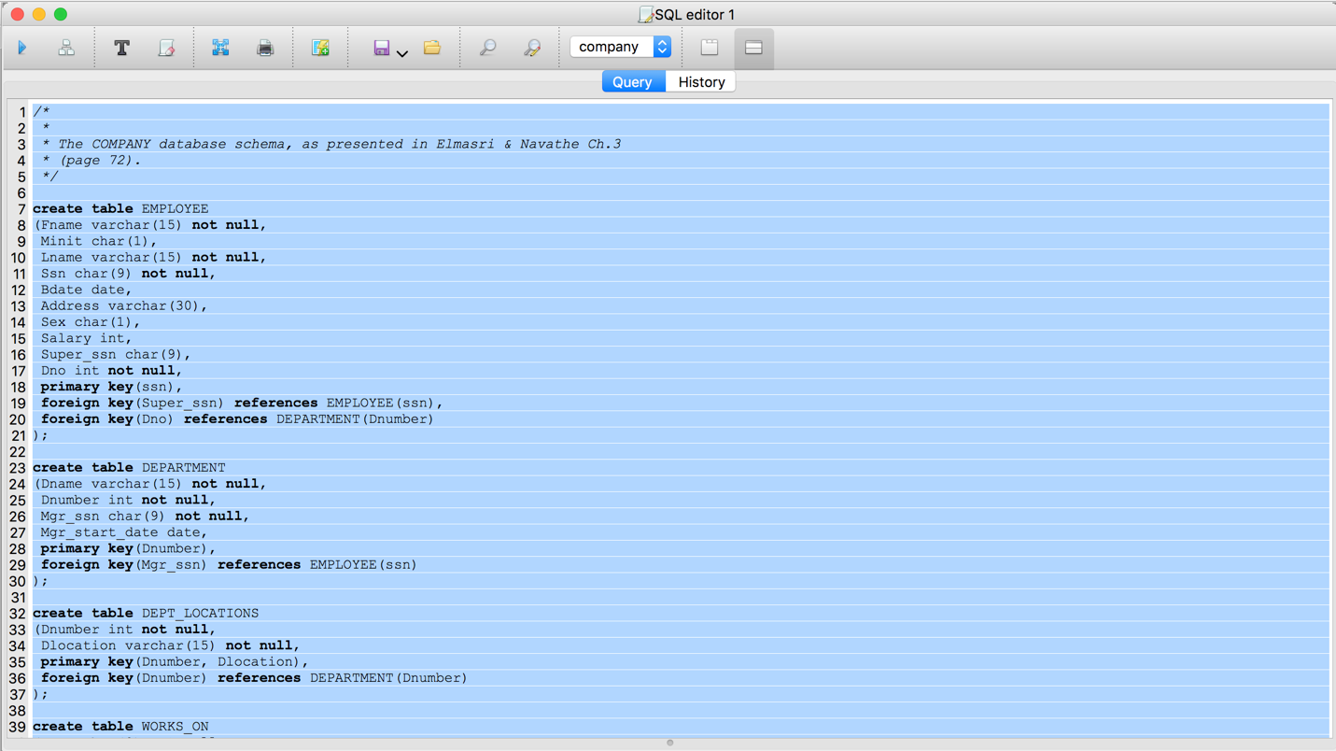

After these steps, you will have defined the company database. You can look at the structure of your database in the “Databases” window, and double click on a table to see more details:

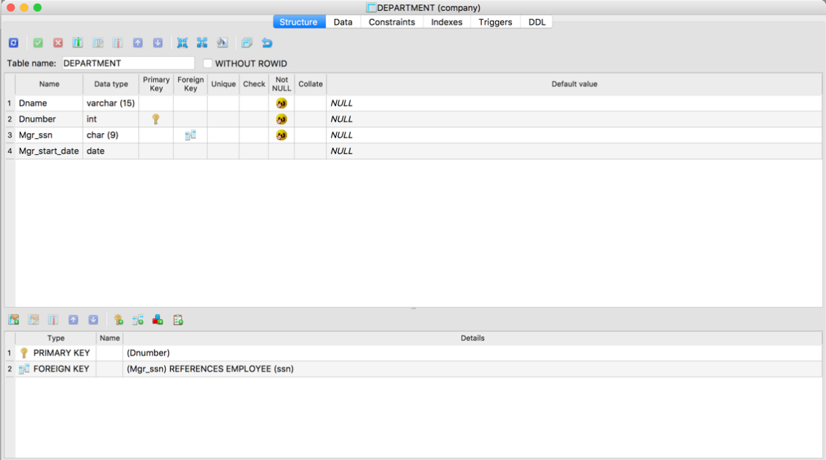
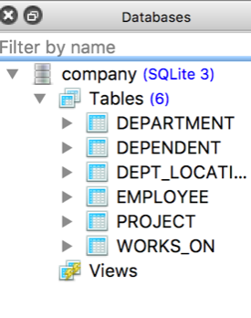

Part 3:
3a. Import data – DML

- To import data using the user interface, click on “tools” at the top of the screen and select “import” from the dropdown menu.

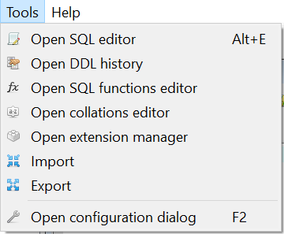

- Choose the database you desire to import to from the left dropdown menu and select the desired table in that database from the right dropdown menu. Click next.

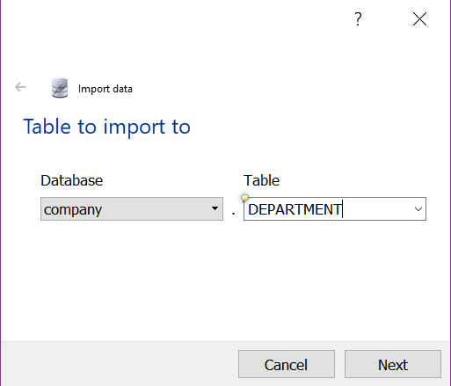

- Select CSV for “Data Source Type” and give the path of the desired .csv file by clicking on the folder icon and selecting the file from the proper directory. Choose System as the text encoding and then click Finish. Repeat steps 1-3 for every table in your database.

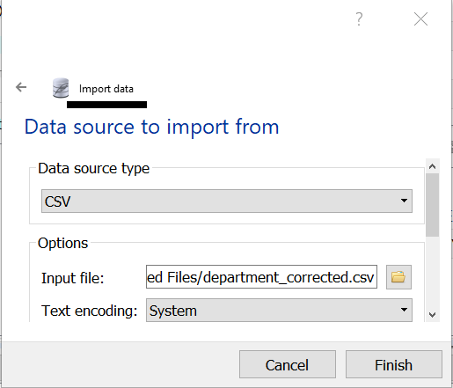

Note: In case you choose not to define the FOREIGN KEY constraints before importing the data, you can create the constraints manually using the graphical interface after importing the data. See below.

- To add the foreign key constraints to your tables, select the icon pointed to by the arrow.

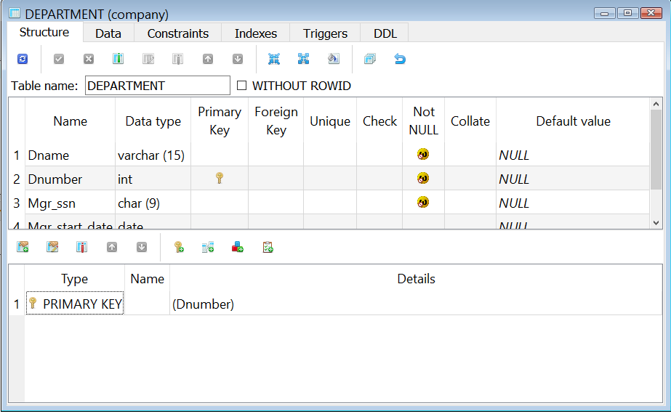

- Select “Foreign Key” from the following window.

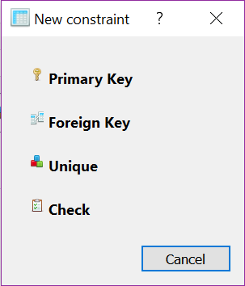

- The following image shows the necessary fields for adding a foreign key constraint to the department table. You will need to specify the foreign table, the local column which references some foreign column, and finally the foreign column which is being referenced. Click create.

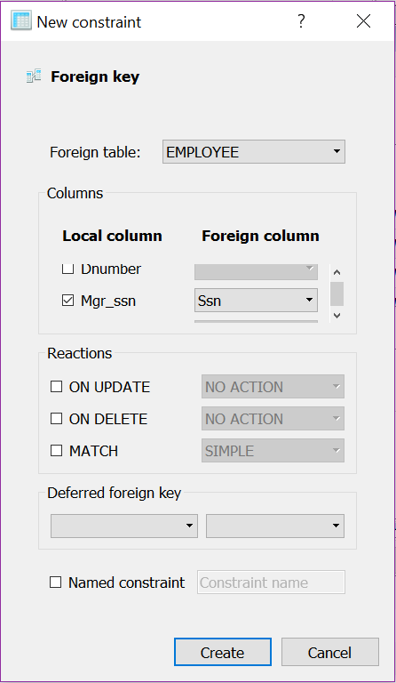
- After adding the foreign key constraints to a table, commit the changes by pressing the button pointed to by the arrow. Press “OK” for the pop up window to confirm the commit. Repeat steps 4-7 for every table which has foreign keys.

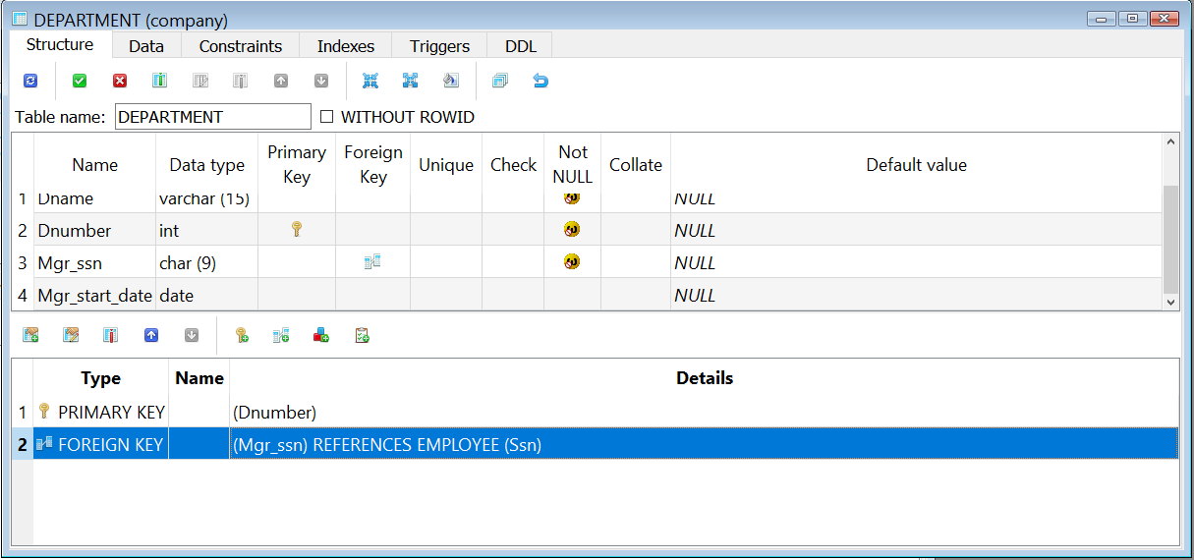
3a. Modifying data on tables – DML
:

Manual Insert Example:
- In order to manually insert a tuple into the Employee table, enter the following code.

INSERT INTO EMPLOYEE VALUES ('Bob','M','Jones','999999999','1973-01-01','123 Fake St., Columbus, OH','M',30000,'333445555',5);

Validate that you did insert the value into the employee table. Go that table and verify (you may need to commit the insertion to have the data inserted and apply the modification)

Manual Update Example:
- In order to manually update a tuple in the Employee table, enter the following code.

UPDATE EMPLOYEE SET Address='234 Imaginary Blvd., Columbus OH' WHERE Ssn='999999999';

Manual Delete Example:
- In order to manually delete a tuple from the Employee table, enter the following code.

DELETE FROM EMPLOYEE WHERE Fname = 'Bob' AND Lname = 'Jones';

Submission Instructions

We are going to use two different ways to submit the database you just created (do both and submit both files):

- Look in the folder where you placed the database file, there should be a file company.db. This is the binary database file (this is the name, if you follow the instructions at the beginning, or another name if you created it using a different name). Upload that file as part of the submission.
- In SQLiteStudio, go to Database menu and select the option “Export the database”. Then be sure to select all the tables as well as the option “Export data from tables” is marked. Press Next. In the Export Format, choose SQL; then specify the file path and the name to store the file. Click finish.
  - Before submitting this file, examine it by opening with Notepad or a similar editor. What does it contains?.
This will create a SQL backup file with the sql script to recreate the database structure and the data in each one of the tables. This method is a way to save a backup and be able to re-build everything from scratch (in case of a disaster).

